# **LAB#01**

* **TASK 01: Modify the sample code so that the sender uses the same socket to send the same message to two different receivers. Start the two receivers first, then the sender. Does each receiver receive the message? Capture the code and output. Describe the outcome.**

### SENDER (CLIENT) PROGRAM:

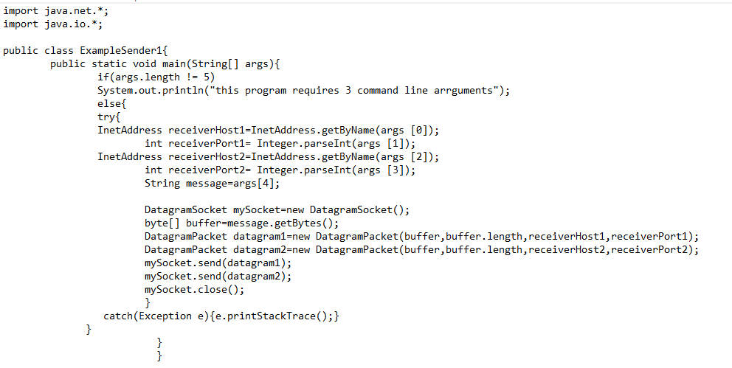

### RECEIVER (SERVER) PROGRAM:

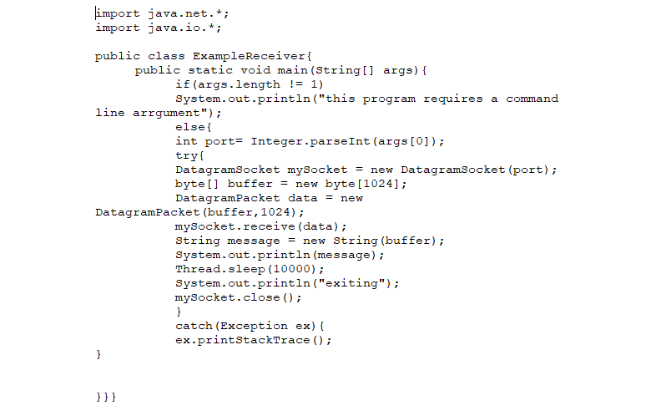

### OUTPUT:

SENDER: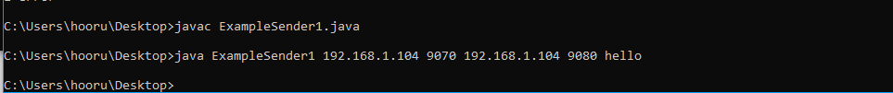

RECEIVER 1:

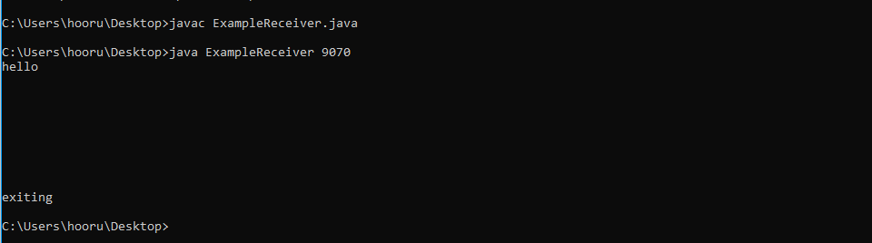

**RECEIVER 2:**

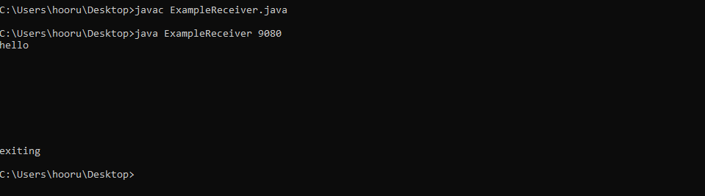

* **TASK 02: Modify the sample code so that the receiver loops six times to repeatedly receive then display the data received. Recompile.**

**RECEIVER PROGRAM:**

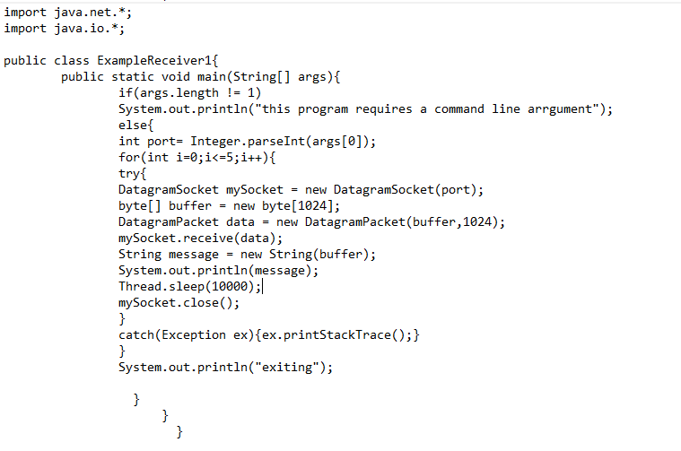

**SENDER PROGRAM:**

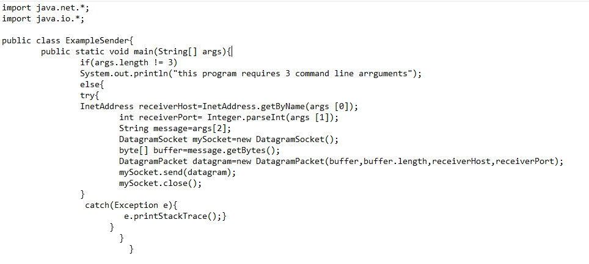

**OUTPUT:**

**Sender:**

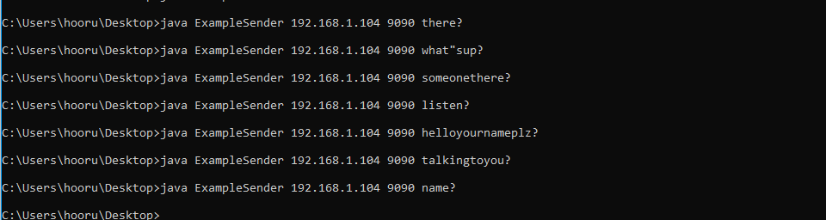

**Receiver:**

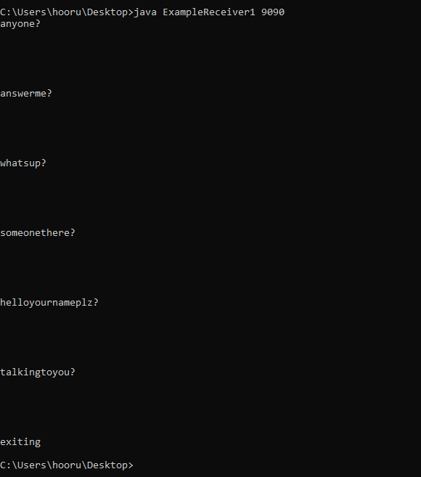

* **Modify the sample code to cater to a two way communication i.e. Sender sends a message to the Receiver, the Receiver receives the message and sends a reply to the Sender in return.**

**Sender program:**

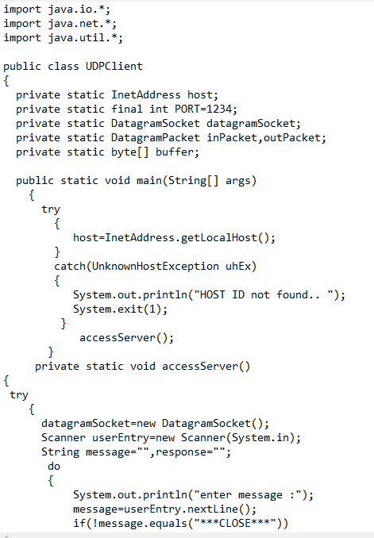

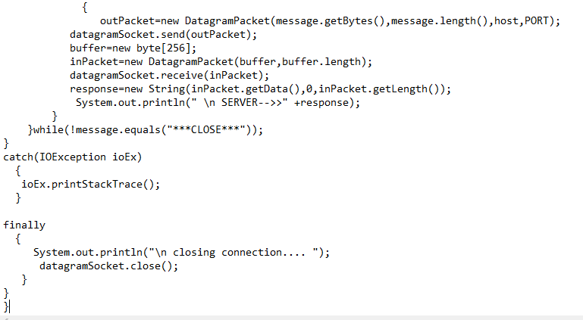

**Receiver program:**

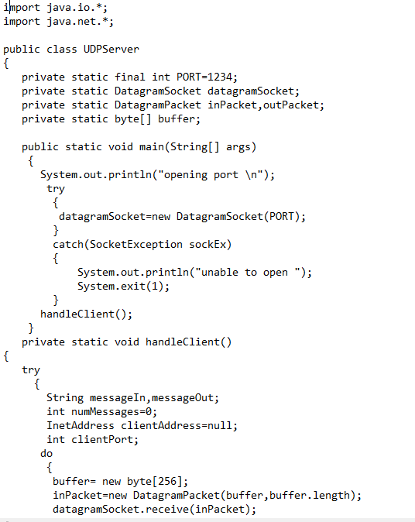

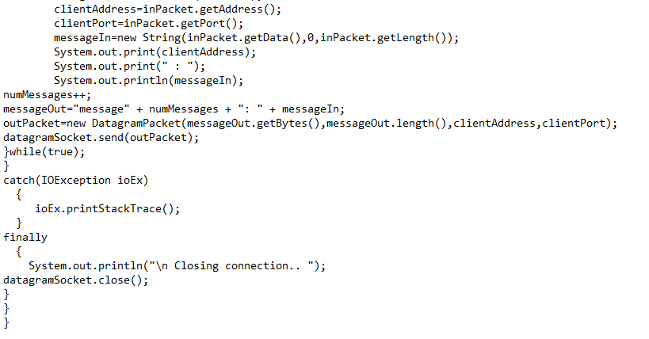

**OUTPUT:**

